The Only Baltimore We Have

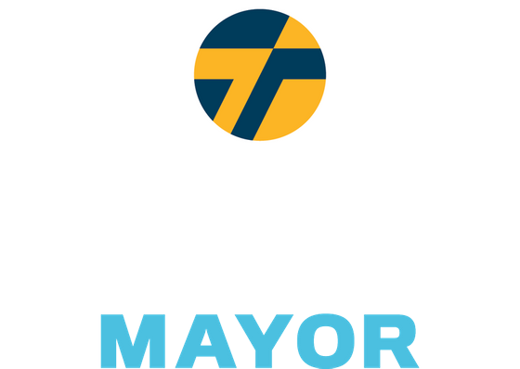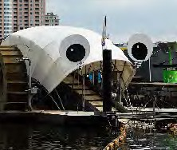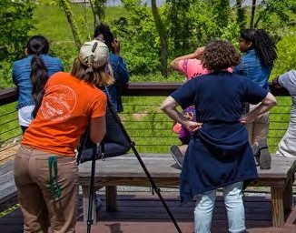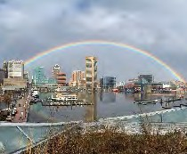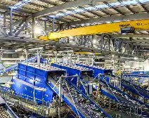

***Baltimore has an opportunity to reimagine its role in battling the defining challenge of our generation.***

***This will require City leadership, regional cooperation, and global innovation. As Mayor, Thiru will:***

# Close the Incinerator

Baltimore will shut down the incinerator by permanently ending our contract, working with the County to pressure Macquarie to replace the incinerator with a mixed-waste materials recovery facility (MRF), and develop a true circular economy around it.

# Expand the Tree Canopy

Baltimore will expand its tree canopy from 27% to 40% in 10 years, integrating this commitment in city schools and creating workforce development opportunities for trade schools in landscaping.

# Clean the Streets & Waterways

Across our city, you will encounter overflowing trash cans, dumped debris, and litter in our streets and waterways. We will establish twice weekly trash pick ups, double the number of trash cans on the streets, create a clean streets index, hold dumpster weekends, and crack down on illegal dumping.

# Reimagine Public Transit

We will expand free bus circulator routes along west-east corridors and key arteries to disinvested communities, with the ultimate goal of a citywide free bus system in 5-10 years. Baltimore will also establish dedicated public transit passages exclusively for buses, pedestrians, scooters, and bikes. This will complement a comprehensive pedestrian-bike plan that would create a 35-mile trail loop.

# Guarantee Green Development & Water Equity

We will mandate green design (e.g., rain gardens) for all developments and become the first major city to prohibit water shutoffs for unpaid bills and freeze water bill debt. We will conduct free water testing, provide filtration systems, and rebuild our crumbling water and sewage system.